PROJECT ON

Student Management System

FOR AISSCE 2022 EXAMINATION

[AS A PART OF COMPUTER SCIENCE COURSE]

**SUBMITTED BY**:-

**NAME**: Khushal Yadav

**ROLL**: 36

[-UNDER THE GUIDANCE OF MS. P DEEPTI (HOD)]

CERTIFICATE

This is to certify that Khushal Yadav of class XII-B has successfully completed the project work under guidance of P Deepti. He has done work in all in original and finished it due course of time as per CBSE guidelines.

**Name**: Khushal Yadav

**Class**: XII-A

**Section**: B (Science)

**HOD PRINCIPAL**

**Ms. P Deepti** **Ms. Monika Mehan**

ACKNOWLEDGEMENT

I undertook this Project work, as the part of my XII Computer Science course. I had tried to apply my best of knowledge and experience, gained during the study and class work experience. It requires a systematic study, insight vision and professional approach during the design and development. I would like to extend my sincere thanks and gratitude to my teacher Ms P Deepti.

I sincerely thank my friends and classmates for their valuable suggestions and assistance as well.

CONTENT

* Introduction
* Project Details
* Objective and Scope of project
* System Requirement
* Python and MySQL
* Python Program
* Prints of Outputs

PROJECT DETAILS

This project is about managing student record. It consists Of Inserting Student ID , Rollno , Class   
Editing it (Delete, Update) And searching for a particular student by his Rollno. from database .

SCOPE AND LIMITATIONS OF THE PROJECT

SCOPE:

Project is very simple and easy to understand.  
Modification of this project can come handy for various things like attendance , report card , Assignments Record .The data can be modified as per need

LIMITATIONS:

Data added is limited to Student Name , Rollno and Class.

USES AND REQUIREMENTS:

SOFTWARE USED:

* Microsoft Windows 10 as Operating System.
* Python 3.7 as Front-end Development environment.
* MySQL as Back-end Sever with Database for Testing.
* MS-Word 2007 for documentation.

NEEDS TO RUN THIS CODE:

* Python Installed.
* MySQL Installed.

CODE:  
from sqlite3.dbapi2 import Cursor

from tkinter import *

import mysql.connector as sqlcon

mycon=sqlcon.connect(host="localhost",user="root",passwd="1234",database="project")

if mycon.is_connected():

    print("successfully connected to mysql database")

import tkinter.messagebox as MessageBox

def insert():

    StudentID=e_StudentID.get()

    Rollno =e_Rollno.get()

    StudentClass=e_StudentClass.get()

    if(StudentID=="" or Rollno=="" or StudentID==""):

        MessageBox.showinfo("Insert details , All fields are required")

    else:

       con=sqlcon.connect(host="localhost",user="root",passwd="1234",database="project")

       Cursor = con.cursor()

       Cursor.execute("Insert into student values('"+StudentID+"','"+Rollno+"','"+StudentClass+"')")

       Cursor.execute("commit")

       e_StudentID.delete(0, 'end')

       e_Rollno.delete(0, 'end')

       e_StudentClass.delete(0, 'end')

       show()

       MessageBox.showinfo("Insert Status"," Inserted successfully ")

       con.close()

def delete():

    if(e_StudentID.get()==""):

        MessageBox.showinfo("Delete Status","Student is compalsary for delete")

    else:

       con=sqlcon.connect(host="localhost",user="root",passwd="1234",database="project")

       Cursor = con.cursor()

       Cursor.execute("delete from student where ID='"+e_StudentID.get()+"'")

       Cursor.execute("commit")

       e_StudentID.delete(0, 'end')

       e_Rollno.delete(0, 'end')

       e_StudentClass.delete(0, 'end')

       show()

       MessageBox.showinfo("Delete Status"," Deleted successfully ")

       con.close()

def update():

    StudentID=e_StudentID.get()

    Rollno =e_Rollno.get()

    StudentClass=e_StudentClass.get()

    if(StudentID=="" or Rollno=="" or StudentID==""):

        MessageBox.showinfo("Update details , All fields are required")

    else:

       con=sqlcon.connect(host="localhost",user="root",passwd="1234",database="project")

       Cursor = con.cursor()

       Cursor.execute("Update student set name='"+StudentID+"',Rollno='"+Rollno+"' ,StudentClass='"+StudentClass+"'")

       Cursor.execute("commit")

       e_StudentID.delete(0, 'end')

       e_Rollno.delete(0, 'end')

       e_StudentClass.delete(0, 'end')

       show()

       MessageBox.showinfo("Update Status"," Updated successfully ")

       con.close()

def get():

   if(e_StudentID.get()==""):

        MessageBox.showinfo("Fetch Status","Student ID is compalsary for delete")

   else:

       con=sqlcon.connect(host="localhost",user="root",passwd="1234",database="project")

       Cursor = con.cursor()

       Cursor.execute("Select * from xi where ID='"+e_StudentID.get()+"'")

       rows = Cursor.fetchall()

       for row in rows:

           e_Rollno.insert(0, row[1])

           e_StudentClass.insert(0, row[2])

       con.close()

def show():

    con=sqlcon.connect(host="localhost",user="root",passwd="1234",database="project")

    Cursor = con.cursor()

    Cursor.execute("Select * from xi")

    rows = Cursor.fetchall()

    list.delete(0, list.size())

    for row in rows:

        insertData = str(row[0])+'       '+str(row[1])

        list.insert(list.size()+1 , insertData)

    con.close()

root =Tk()

root.geometry("600x500")

root.title('Student database management')

root.bg="yellow"

StudentID = Label(root,text='Enter student ID',font=('bold',10))

StudentID.place(x=20 , y=30)

Rollno = Label(root,text='Enter student Roll no.',font=('bold',10))

Rollno.place(x=20 , y=60)

StudentClass = Label(root,text='Enter student Class',font=('bold',10))

StudentClass.place(x=20 , y=90)

e_StudentID = Entry()

e_StudentID.place(x=150 , y=30)

e_Rollno = Entry()

e_Rollno.place(x=150 , y=60)

e_StudentClass = Entry()

e_StudentClass.place(x=150 , y=90)

insert = Button(root, text="Insert", font=("italic", 10), bg="cyan" ,fg="black" , command=insert)

insert.place(x=20 , y=140)

delete = Button(root, text="Delete", font=("italic", 10), bg="cyan" ,fg="black" , command=delete)

delete.place(x=70 , y=140)

update = Button(root, text="Update", font=("italic", 10), bg="cyan" ,fg="black" , command=update)

update.place(x=130 , y=140)

get = Button(root, text="Get", font=("italic", 10), bg="cyan" ,fg="black" , command=get)

get.place(x=190 , y=140)

list = Listbox(root)

list.place(x=290 , y=30)

show()

'''''

entry ke liye

e= Entry()

e.pack()

root.iconbitmap('C:\\Users\\24sai\\OneDrive\\Desktop\\201818')

def click1():

    thislabel = Label(root, text="Choose the student name")

    thislabel.pack()

#isme create karo

thislabel1= Label(root, text="student management system")

thisbutton= Button(root,text="get started" , padx=30, pady=30, command=click1

,bg="red" , fg="white" , borderwidth=2)

thisbutton.pack()

'''''

root.mainloop()

MYSql Tables:-

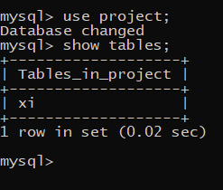

The table here shows the list of students studying in class xi and as per our project we have to manage them , select them ,and even sometimes add some more students(#new admissions)

**As per that we have created our project.  
Now here is the list of all the students:-** 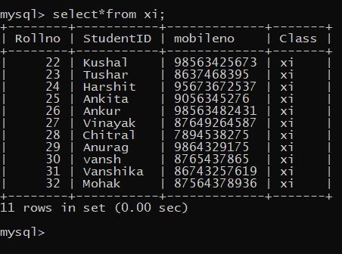

**Python outputs:-  
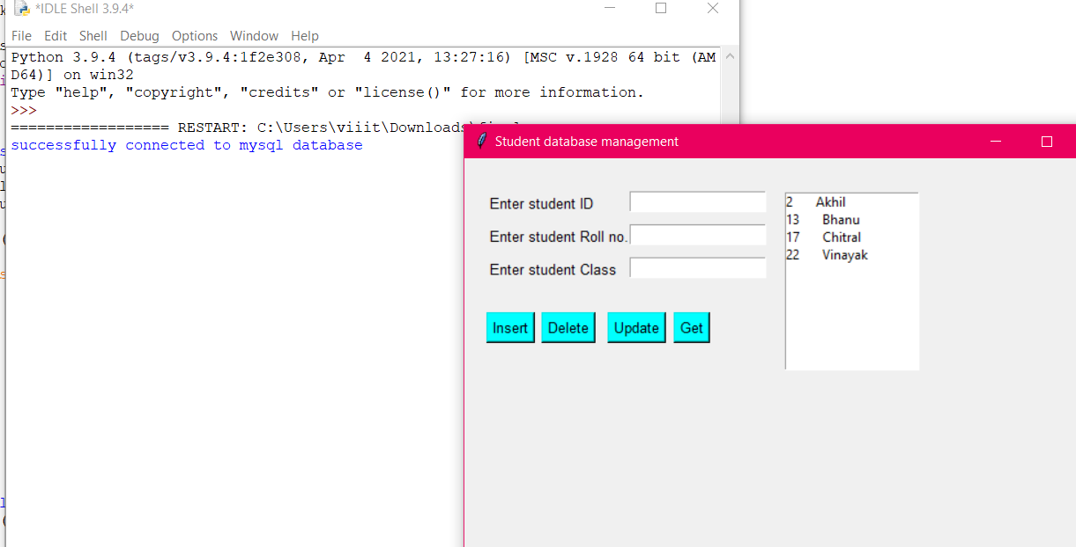**

**-As you can see that in this project we can select, update and remove a student as per the situation occurs in the school.**

**For ex:- currently the students of class xi is showing the box present at right hand side.  
  
if I want to add a new student (new admission) I need to insert his details and then press insert just as shown below:-**

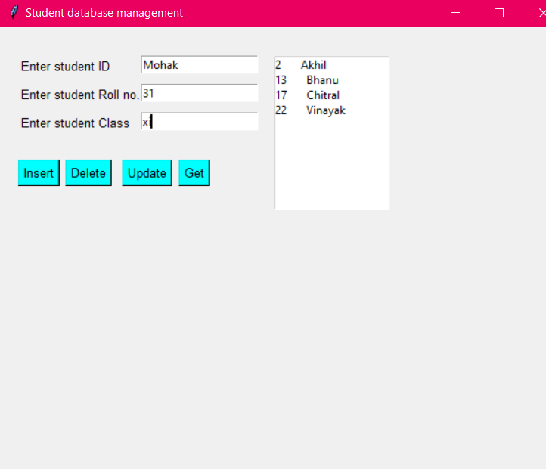

**Now just press insert:-**

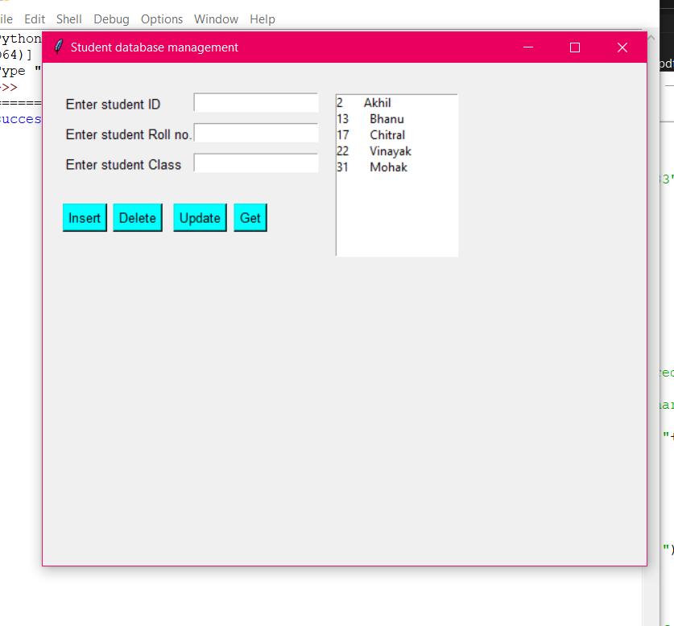

See we got new student’s name in the box /List.

If a Student left the school due to some reasons and we have to update our list we just need to type the information regarding that student and press delete.  
  
Just as shown below:-

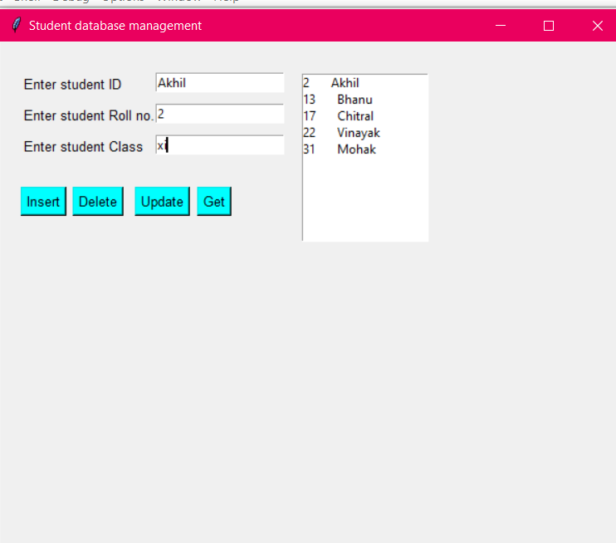

Just after pressing delete we get:-

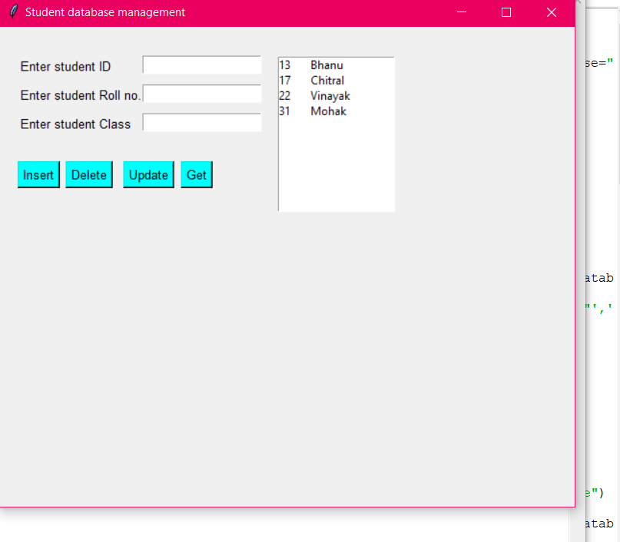

As we can see the student (Akhil) has been removed now.  
  
The function of Get is to select a particular student from a bunch just as shown below:-  
  
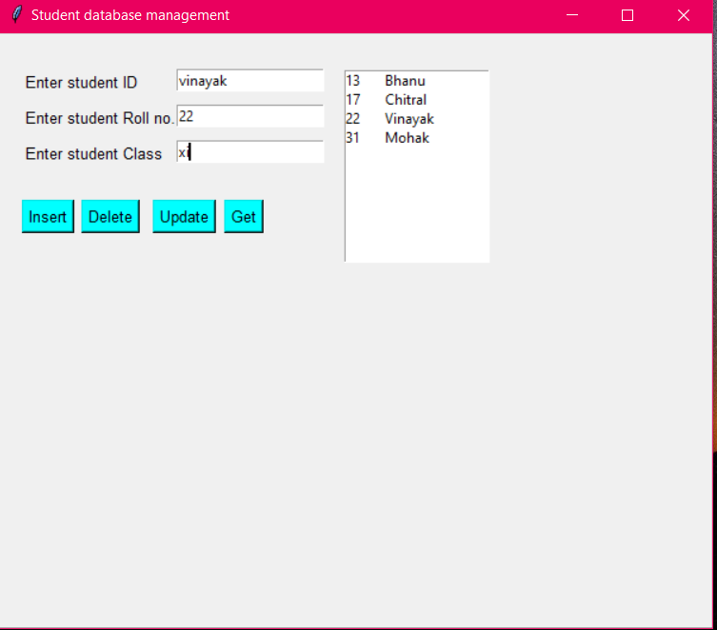

After pressing Get we get:-

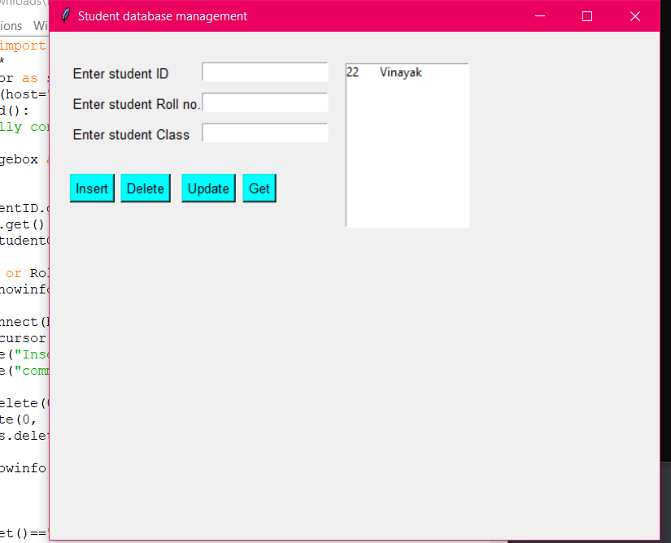

So we just got a selected student from the bunch.  
That’s all from Our side.  
  
Thank you for seeing our project.  
>>Made by:-

Harshit,Tushar,Kushal